Lab 1 report:

In lab1, we have been taught some new tools like scrumdo and Github so that these tools will be helpful in our project.
ER and Class Diagrams

Github Account Screenshot
Github for windows
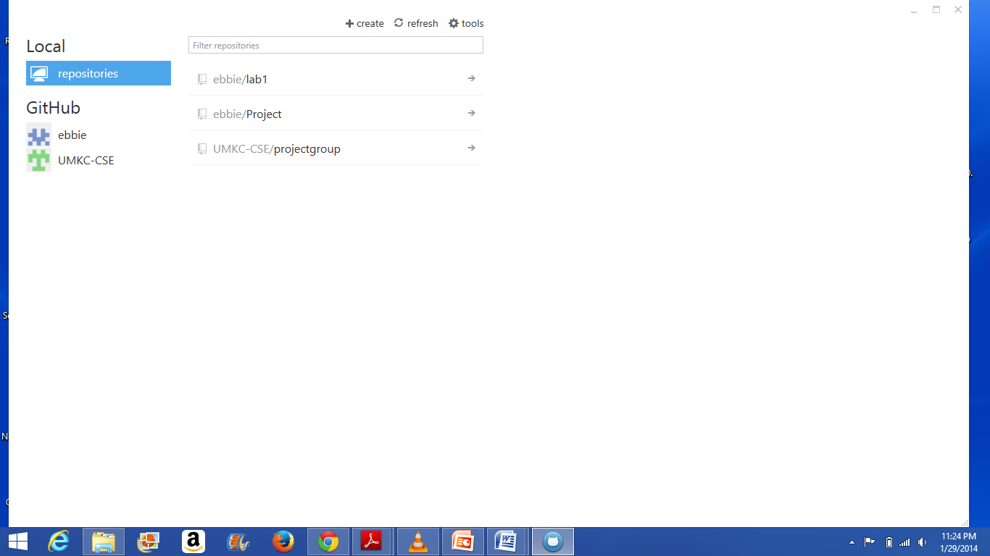
Remote Github
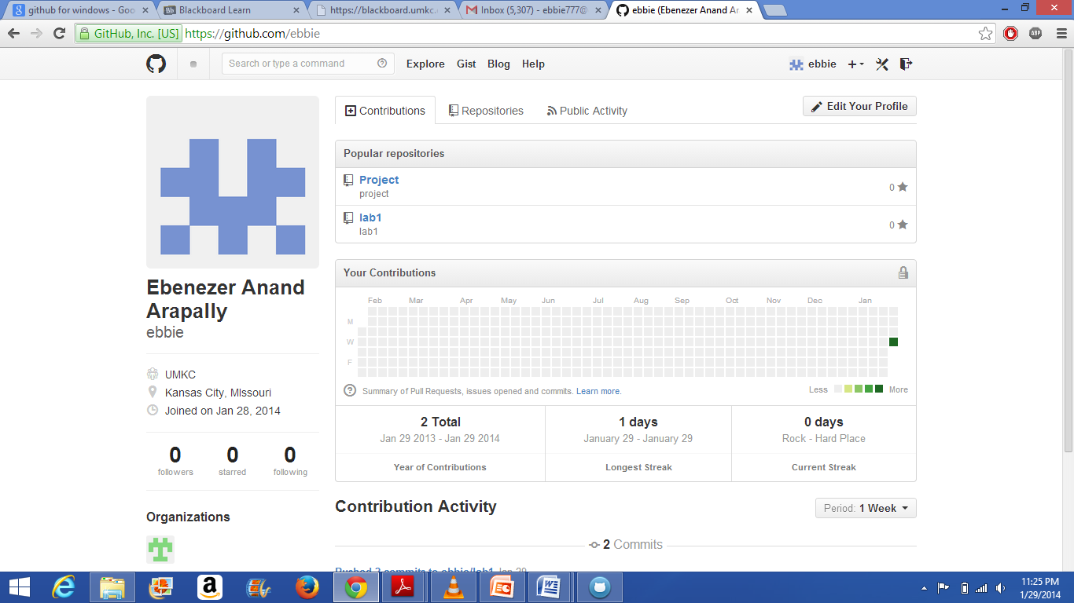

Scrumdo Account Screenshot
